|  |  |  |  |
| --- | --- | --- | --- |
| 1 | | 327,162.85714285716 | |
| NUMERO DE FRONTERAS | | ENERGIA AGREGADA | |
|  | | | |
| SI | | 28/03/2022 | |
| CONTRATO | | VENCIMIENTO CONTRATO | |
|  | | | |
| 1,156,126,323 | 143 | | 43,710,382 |
| INGRESO 2019 | DÍAS CERTIFICADOS 2019 | | ENERGIA RESPALDADA 2019 |
|  | | | |
| 1,177,147,920 | 176 | | 45,857,324 |
| INGRESO 2020 | DÍAS CERTIFICADOS 2020 | | ENERGIA RESPALDADA 2020 |
|  | | | |
| 953,304,525 | 138 | | 41,896,257 |
| INGRESO 2021 | DÍAS CERTIFICADOS 2021 | | ENERGIA RESPALDADA 2021 |

|  |
| --- |
| **FAMILIA CAJICA**  USUARIO |

|  |
| --- |
| **Mateo Porras**  Ejecutivo de cuenta |

|  |
| --- |
| **Thannia Huertas / Especialista Energía Eléctrica / thanniahc@grupofamilia.com**  PUNTO FOCAL |

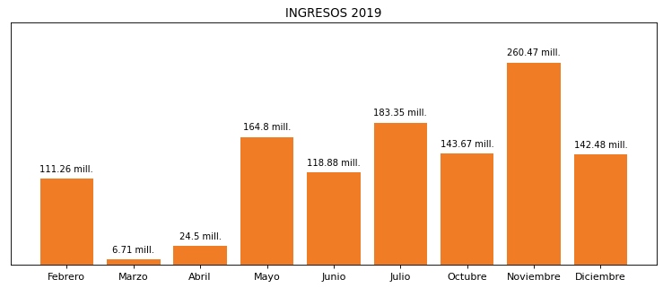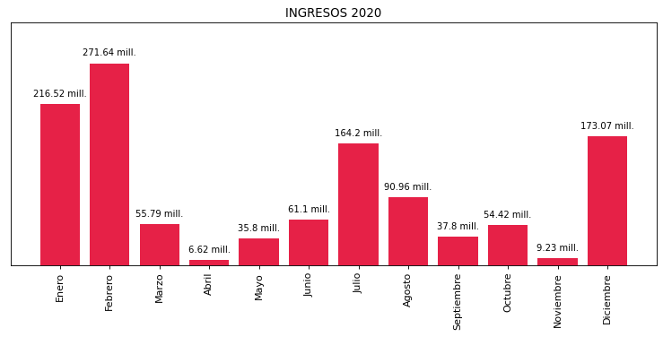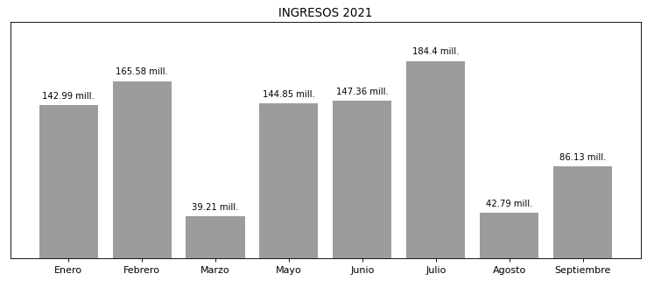

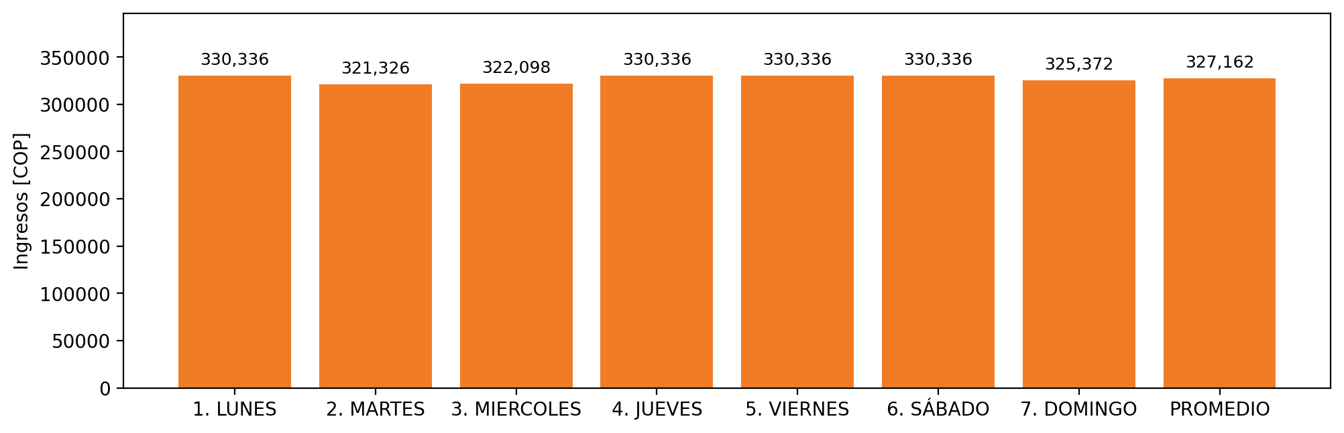

|  |  |  |  |  |  |  |  |  |  |  |
| --- | --- | --- | --- | --- | --- | --- | --- | --- | --- | --- |
| **FRONTERA** | **COD SIC** | **PREDIO** | **FRT DDV** | **TIPO DDV** | **PROMEDIO** | **PRÓXIMA ACTUALIZACIÓN** | **MARGEN DE ERROR** | **ÚLTIMA PRUEBA DDV** | **DÍAS PARTICIPACIÓN** | **FECHA REFERENCIA PRÓXIMA PRUEBA DDV** |
| PRODUCTOS FAMILIA S.A. 1 | Frt05879 | Prd01151 | Frt31827 | LBC | 327,162 | 2021-12-07 | 4,54 | 2021-09-27 | 0.0 | 2022-02-13 |